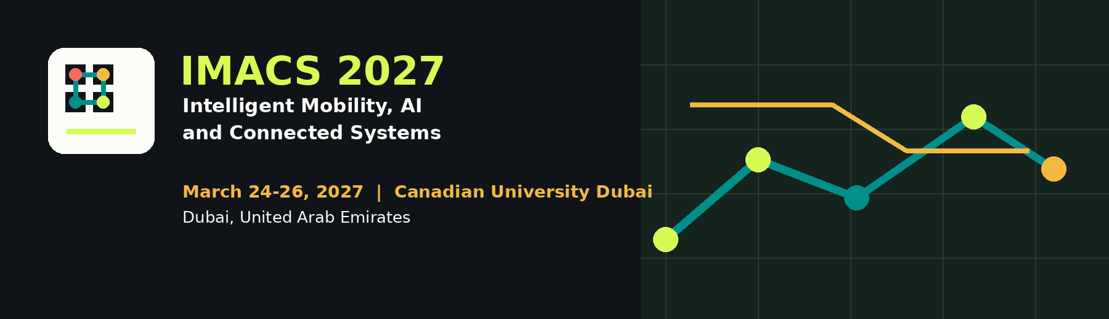
CALL FOR PAPERS
International Conference on Intelligent Mobility, AI and Connected Systems
IMACS 2027 invites original, unpublished full papers on intelligent mobility, artificial intelligence, connected systems, and smart city technologies.
DATES  March 24-26, 2027 | VENUE  Canadian University Dubai | LOCATION  Dubai, United Arab Emirates
Scope
IMACS 2027 is a premier international forum for researchers, practitioners, industry leaders, technology providers, city planners, and policymakers to present and discuss advances in intelligent mobility, artificial intelligence, connected systems, and smart city technologies.
The conference aims to foster interdisciplinary collaboration and facilitate the exchange of innovative ideas that will shape the future of mobility, connectivity, sustainability, and urban intelligence.
Important Dates
Paper submission deadline | November 1, 2026
Notification of acceptance | January 1, 2027
Camera-ready paper submission | February 1, 2027
Conference dates | March 24-26, 2027

Conference Tracks
Intelligent Mobility and Transportation Systems  - AI and machine learning for transportation systems  - Connected and autonomous vehicles  - V2X communications and cooperative perception  - Smart logistics, MaaS, safety, and traffic control | Artificial Intelligence and Data-Driven Systems  - Foundation models, generative AI, and LLMs  - Edge AI, distributed intelligence, and multi-agent systems  - Spatio-temporal analytics and real-time stream processing  - Explainable, trustworthy, and privacy-preserving AI

Connected Systems and Smart Infrastructure  - IoT, edge-cloud computing, and 5G/6G systems  - Cyber-physical systems and digital twins  - Smart city platforms, energy systems, and buildings  - Cybersecurity, interoperability, and resilient infrastructure | Policy, Governance and Societal Impact  - AI governance, standards, and regulatory frameworks  - Mobility data sharing, privacy, and ethical AI  - Public policy, accessibility, and smart city governance  - Workforce transformation and digital inclusion

Submission and Publication
- Authors are invited to submit original, unpublished full papers describing completed or ongoing research.
- All submissions will undergo a rigorous peer-review process by at least three independent reviewers.
- Publication and proceedings details will be announced after approvals and proceedings arrangements are finalized.
Publication Details
Final publication, proceedings, indexing, and submission instructions will be published after approvals and proceedings arrangements are finalized.
Contact: info@ieee-imacs.org | Website: https://ieee-imacs.org/ | Canadian University Dubai, City Walk, Dubai, UAE

